**Suppliers+ Inventory**

Ali Abass: 212922553

Maged natour : 212066260

Lana farraj : 324917293

Mohamd assi : 322715871

1)**Use Case:**

**A:**

C+d+e+f:

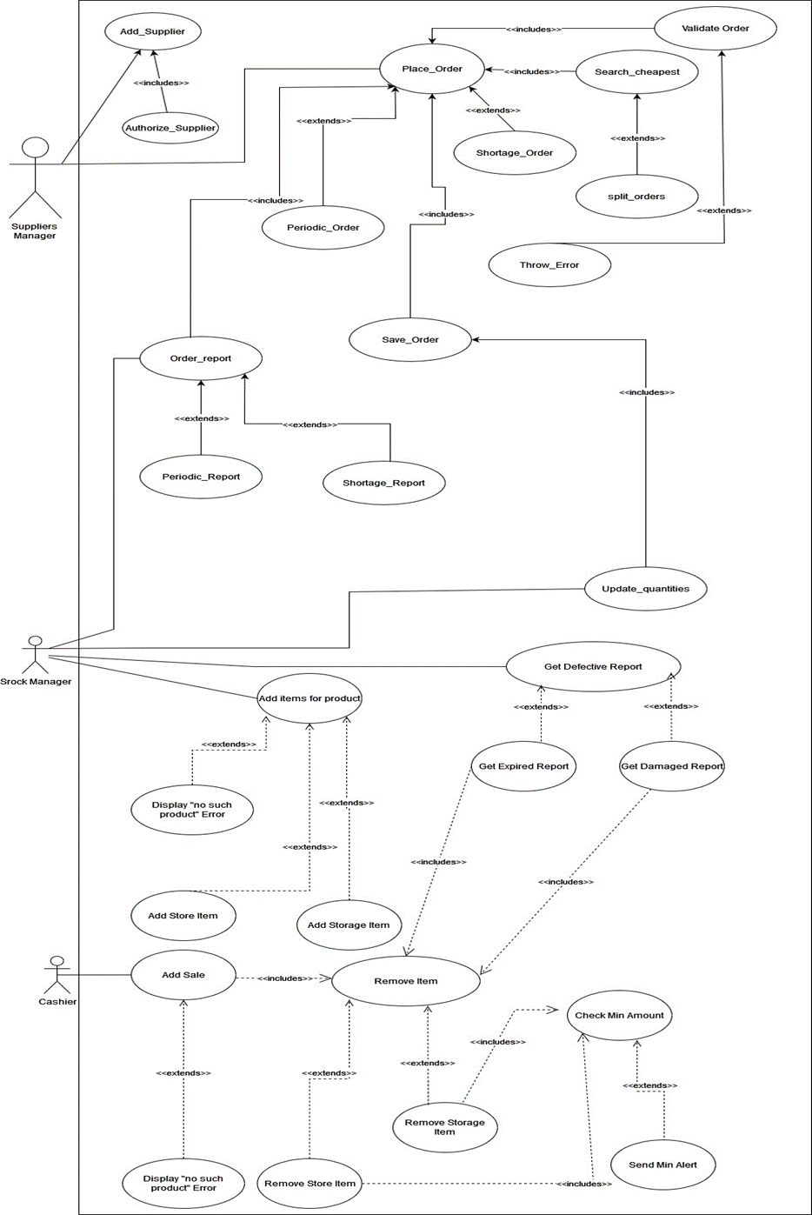

a+b+g+h:

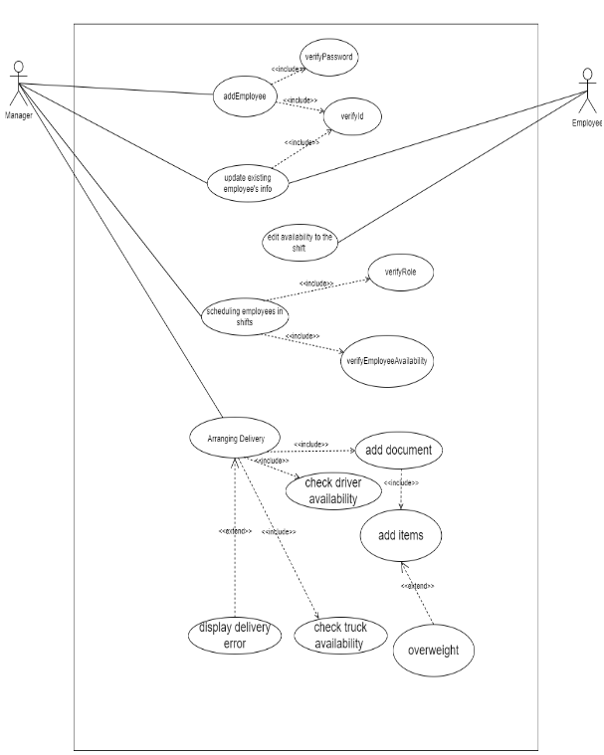

**B:**

|  |  |
| --- | --- |
| Use case name | Placing a periodic order. |
| Textual Description | This use case represents an action of placing an order in a fixed time . |
| List of Actors | Suppliers manger and Stock manger. |
| Pre-conditions | The order must be updated at least a day before or an there is an existing order that we will order again.  There must be a contract with the supplier.  The stock manger must have provided an items report or updates an existing periodic order  at least one day before the delivery. |
| Post-conditions | A successful message will be shown.  The order is saved in the order history. |
| Main success scenario | -The suppliers manger validates the report.  - The suppliers mangers find the cheapest provider for the corresponding report.  -The order is saved in the system.  -The stock manger updates the quantity accordingly. |
| Alternatives/Extensions | -The suppliers mangers tries to find the best deal for the report , If there is no supplier that can provide the order an error should be displayed.  -The suppliers mangers receives the order report ,if there is a mistake in the provided order report an error will be displayed. |

|  |  |
| --- | --- |
| Use case name | Placing a shortage order. |
| Textual Description | When the manager gets a warning from the system that an item has reached its minimum amount, he has to make a new order and he has to set the amount to order at least as the minimum amount of the item |
| List of Actors | Suppliers manger and Stock manger. |
| Pre-conditions | There must be a contract with the supplier.  The item stock amount has to be in defined shortage amount. The stock manger gets a warning for the items that reached the minimum amount. |
| Post-conditions | A successful message will be shown.  The order is saved in the order history. |
| Main success scenario | -The stock manger provide an order report .  -The suppliers manger validates the report.  - The suppliers mangers find the cheapest provider for the corresponding report.  -The order is saved in the system.  -The stock manger updates the quantity accordingly. |
| Alternatives/Extensions | -The suppliers mangers tries to find the best deal for the report , If there is no supplier that can provide the order an error should be displayed.  -The suppliers mangers receives the order report ,if there is a mistake in the provided order report an error will be displayed.  - The suppliers mangers tries to find the cheapest deal for the report If there is not a single supplier that can provide the order , the order will be split and the system will choose the cheapest division. |

